Schematic Sheet | Description
Top Sheet
Power Section
MCU Core Power | Power Sources  - VBAT_SYS – What is the voltage level?  - VCCIP0_CORE_DC – What is the voltage level?  Components  - 6V/3.5A, Fast Response, Adaptive COT Step-Down Converter in Tiny DFN2x2  Datasheet – ETA3451D2I-T https://drive.google.com/file/d/1XjPJf44RNFbel47kCcIjx50fKOjKllRC/view?usp=sharing  Description  ETA3451 belongs to a new breed of high frequency synchronous Step-Down converters that combines the advantages of voltage mode control and Constant-On-Time control. Its adaptive Constant-On-Time control dynamically changes switch on time to achieve a constant switching frequency. It does not have the minimum on-time constrain normally a fixed-frequency current mode Step-down requires, allowing it to go down to very low duty ratio without affecting loop stability. The voltage mode nature of ETA3451 also provides more superior load transient response and a seamless transition from Pulse Frequency Modulation (PFM) to Pulse Width Modulation (PWM) modes. ETA3451 is capable of supplying output with current up to 3.5A at 1.2V output. All these features make ETA3451 an excellent choice for ARM based CPU power supply. ETA3451 is in a tiny DFN2x2-8Lpackage.  Features  - Adaptive COT control  - Up to 95% Efficiency  - Up to 91% Efficiency for low output voltage  - Up to 3.5A Max Output current  - Feedback voltage 0.45V  - Excellent load transient response  - DFN2X2-8L Package  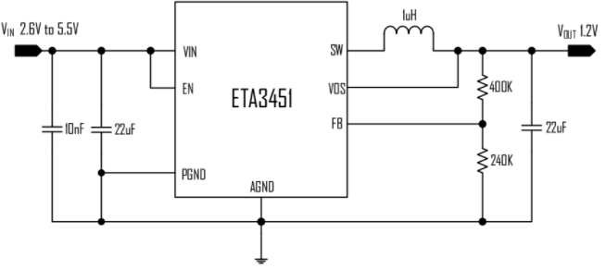  Typical Application - Circuit of 1.2V Output
USB Power | Power Sources  - VBAT_USB – What is the voltage level?  - LVDS_VDD – What is the voltage level?  - VCC3P3_SYS – What is the voltage level?  - VBAT_SYS – What is the voltage level?  - 2.7A, 1.2MHz, High-Efficiency Step-Up Converter with Input Disconnect  Datasheet MP3221GJ-Z  https://drive.google.com/file/d/16WZVa2xYAE9JyGfPRwQkRSHuI5i3-Qb_/view?usp=sharing  Description  The MP3221 is a 1.2MHz frequency, 6-pin TSOT23 current mode step up converter intended for small, low power applications. The device can step up three-cell alkaline, NiCd, and NiMH batteries, or a single-cell Li-on battery up to 6V. It is capable of delivering 1A output current at 5V with a supply voltage of 3V. The MP3221 provides the internal soft start and compensation to minimize the external component count and help producing a compact solution. It integrates a FAULT driver for external PMOS to disconnect the output from input when the part shuts down or in output short circuit condition. This disconnect feature allows the output to be completely discharged, thus allowing the part to draw less than 1μA off current in shutdown mode. The MP3221 is available in a small 6-pin TSOT23 package.  Features  - Integrated 88mΩ Power MOSFET  - 270μA Quiescent Current  - 2.5V to 6V Input Voltage  - 3V to 6V Output Voltage  - 1.2MHz Fixed Switching Frequency  - Internal 2.7A Switch Current Limit  - Integrated Input Disconnect Driver  - Internal Soft Start and Compensation  - True Output Disconnect from Input  - Under Voltage Lockout  - Short-Circuit Protection  - Over-Temperature Protection  - Available in a 6-Pin TSOT23-6 Package  Applications  - Single-Cell Lion Battery or Three-Cell Alkaline, NiCd, or NiMH Battery Based Products  - Portable Media Players  - Wireless Peripherals  - Tablets and Smart Phones  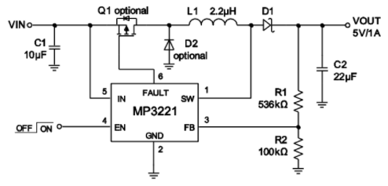  Diagram - Typical Application  - SOT-23 Plastic-Encapsulate MOSFETS  Datasheet CJ2305  https://drive.google.com/file/d/1OT3KeYp2cjUi-N5ibpDGFgZ-Yf5CM7c3/view?usp=sharing  Feature  - TrenchFET Power MOSFET  Application  - Load Switch for Portable Devices  - DC/DC Converter  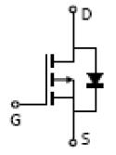  Typical Application
RTC Section | Power Sources  - VCC 1P8_RTC - What is the voltage level?  - VBAT_SYS# - What is the voltage level?  - Surface Mount Fast Switching Diode  Datasheet 1N4148W-7-F BAT  https://drive.google.com/file/d/1pMWrj3LNtGiDIUtWLONlCUWwSaPoR7xA/view?usp=sharing  Features  - Fast Switching Speed  - Low Forward Voltage: Maximum of 0.715V at 1mA  - Fast Reverse Recovery: Maximum of 4ns  - Low Capacitance: Maximum of 2pF  - Surface Mount Package Ideally Suited for Automated Insertion  - For General Purpose Switching Applications  - Totally Lead-Free & Fully RoHS Compliant (Notes 1 & 2)  - Halogen and Antimony Free. “Green” Device (Note 3)  - Qualified to AEC-Q101 Standards for High Reliability  - PPAP Capable (Note 4)  - Ultra-Low Current Consumption and Low Dropout Cmos Voltage Regulator  Datasheet S-1206B18-M3T1U  https://drive.google.com/file/d/11JNy0JxpWSveVUC_rDiVuLjXPk1y6toH/view?usp=sharing  Description  The S-1206 Series is a positive voltage regulator with ultra-low current consumption, low dropout voltage, high-accuracy output voltage, and 250 mA output current developed based on CMOS technology. I/O capacitors are as small as 0.1 F. S-1206 Series operates at ultra-low current consumption of 1.0 A (typ.). The built-in low-on-resistance transistor realizes low dropout voltage and a large output current. A built-in overcurrent protection circuit prevents the load current from exceeding the current capacity of the output transistor. Three packages, SOT-23-3, SOT-89-3, and SNT-6A(H) are available. Compared with voltage regulators using a conventional CMOS technology, more types of capacitors, including small I/O capacitors, can be used with the S-1206 Series. The S-1206 Series features ultra-low current consumption and comes in a small package, making them most suitable for portable equipment.  Features  - Output voltage: 1.2 V to 5.2 V, selectable in 0.05 V step  - Input voltage: 1.7 V to 6.5 V  - Output voltage accuracy: 1.0% (1.2 V to 1.45 V output product: 15 mV)  - Dropout voltage: 150 mV typ. (3.0 V output product, IOUT = 100 mA)  - Current consumption: During operation: 1.0 A typ., 1.5 A max.  - Output current: Possible to output 250 mA (3.0 V output product, VIN VOUT(S) 1.0 V) *1  - Input and output capacitors: A ceramic capacitor of 0.1 F or more can be used.  - Built-in overcurrent protection circuit: Limits overcurrent of output transistor.  - Operation temperature range: Ta = 40°C to 85°C  - Lead-free, Sn 100%, halogen-free*2  Applications  - Constant-voltage power supply for battery-powered device  - Constant-voltage power supply for cellular phone  - Constant-voltage power supply for portable equipment  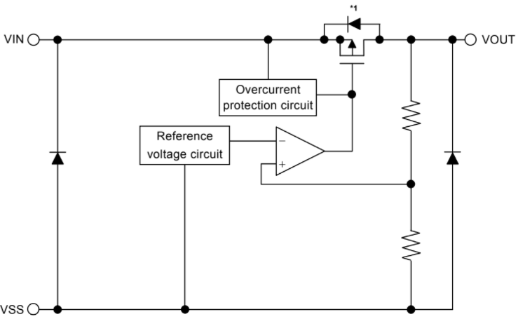  Typical Application
Audio Section
MIC | Datasheet POM-2738P-R
Audio | Power Sources  LVDS_VDD  VCC3P3_SYS  Datasheet ALC5621  Datasheet S2B-XH-A(LF)(SN) JACK
Headphone | Power Sources  VCC3P3_SYS  Datasheet SJ-43504-SMT-TR
3G Section
3G Modem | Power Sources  VCC3P3_SYS  VBAT  Datasheet SIM7100AS2-10671  Datasheet U.FL-R-SMT-1(80)
USIM | Power Sources  VBAT  VBAT_USB  Datasheet 693043020611  Datasheet ESDA6V1-5SC6
Level Shifter | Power Sources  VCC3P3_SYS  VCC IP8_LDO  Datasheet S-1206B18-M3T1U
Controller
Main Controller | Datasheet S5P4418
Camera Section | Datasheet 0524352471
RS 232 Transceiver | Datasheet SP3222EEY-L/TR  Datasheet A-DF 09 A/KG-T4S
LCD Section | Datasheet 4-1734592-2
Connector Section | Power Sources  VBAT
Memory Section | Power Sources  VCC3P3_SYS  Datasheet 114-00841-68
USB Section
USB OTG | Power Sources  DC5V_OTG  VBAT_USB  Datasheet SY6280AAC  Datasheet 10118194-0001LF
USB Host | Datasheet GL850G  Datasheet 87583-2010BLF
Input Section
Key Buttons
Sensor Section | Power Sources  VCC 1P8_LDO  VCC3P3_SYS  Datasheet ICM-42688-P  Datasheet VEML6030-GS15

